# BASIC INTRODUCTION OF REACT

What is REACT?

React is just an JavaScript library and not a framework created by facebook

It is an User Interface Library, it is tool for building UI component.

Why React ?

It is used by more popular companies like facebook, netflex,paypal and many more

1.Fast and Responsive : very fast in rendering UI in browser we can scale it to large complex UI and very efficient to manipulate the DOM.

React operates not directly on the browser's Document Object Model (DOM) immediately, but on a **virtual DOM**. That is, rather than manipulating the document in a browser after changes to our data (which can be quite slow) it resolves changes on a DOM built and run entirely in memory. After the virtual DOM has been updated, React intelligently determines what changes to make to the actual browser's DOM.

2. Composable Component : A component is a self-contained module that renders some output. We can write interface elements like a button or an input field as a React component. Components are composable. A component might include one or more other components in its output.

3.Pluggable : We can render it with any other technologies and add in any code easily

4.Simple to learn: it’s a small library so it is simple to learn

5.Facebook’s brain :React is maintain by facebook so it is main part of it

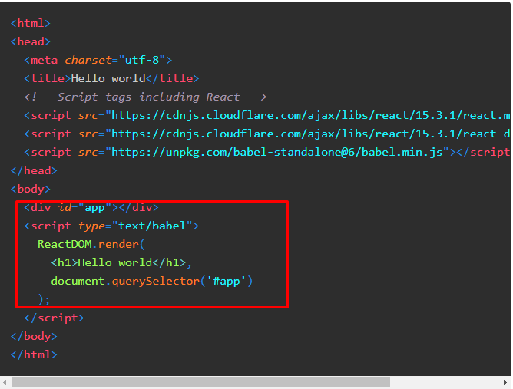

This is how we add React code in Html code

What is JSX?

React components have a render function that specifies what the HTML output of our React component will be. **JavaScript eXtension**, or more commonly **JSX**, is a React extension that allows us to write JavaScript that looks like HTML.

imagine we had a React component that renders an h1HTML tag. JSX allows us to declare this element in a manner that closely resembles HTML:

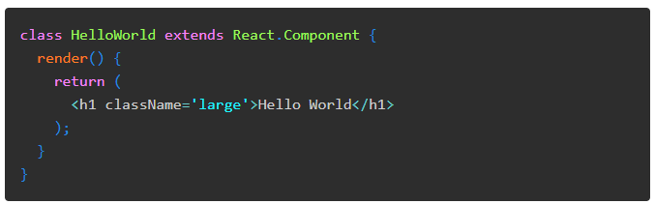

Basic Structure of React Component

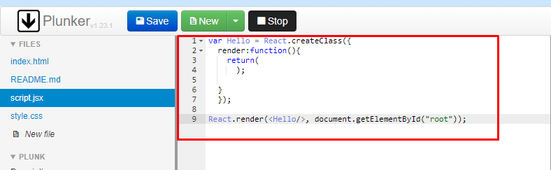

Hello World Code

Index.html

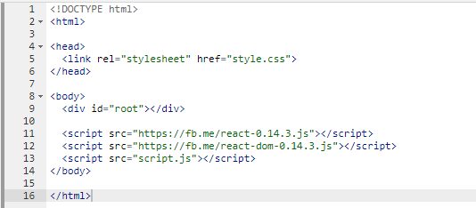

Script.JSX :

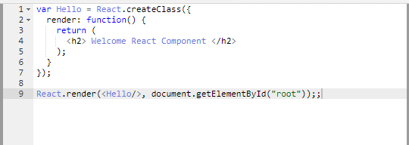

Event Handling :

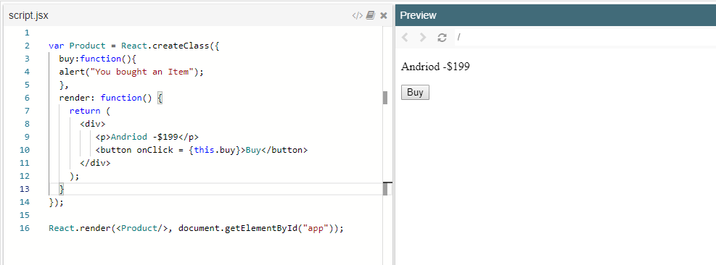

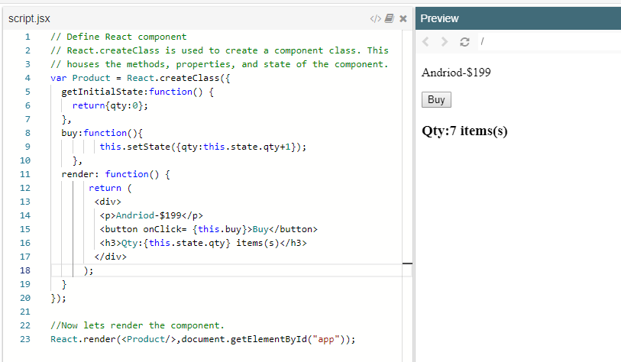

Reusable Component

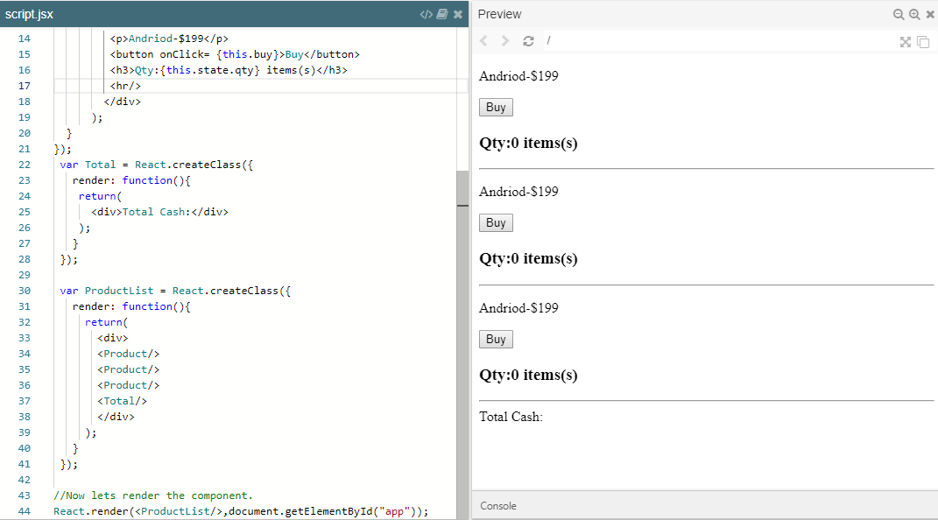

Passing data as parameters

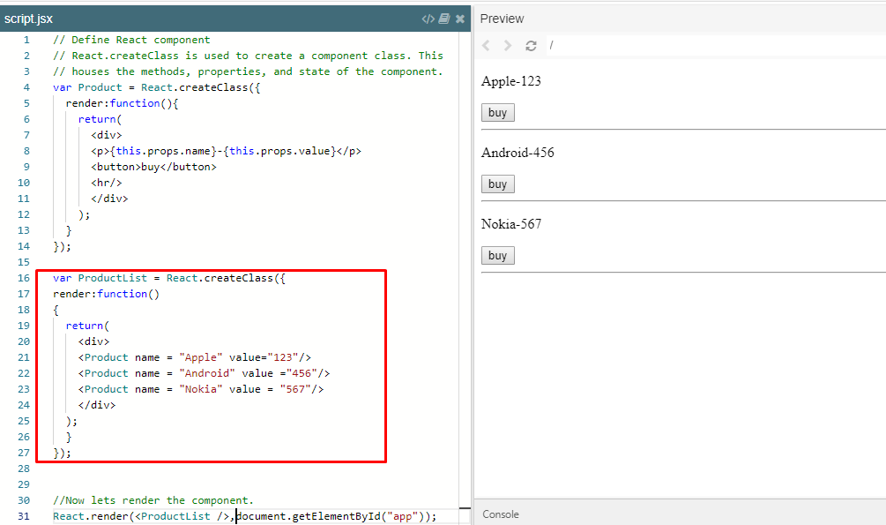

Working with Property- function

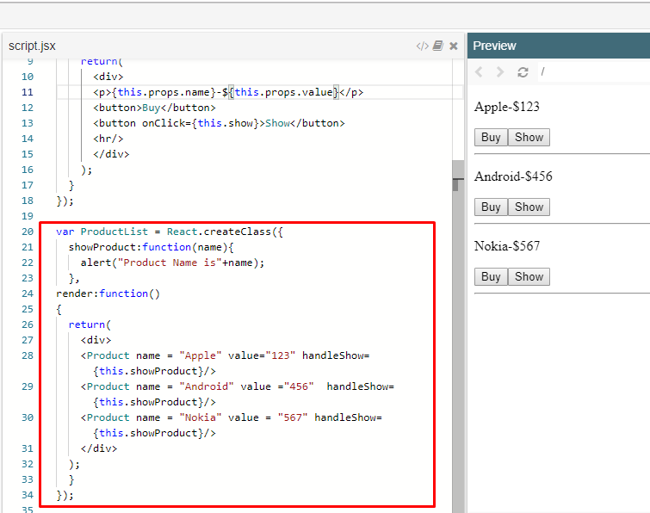

Get data from child component:

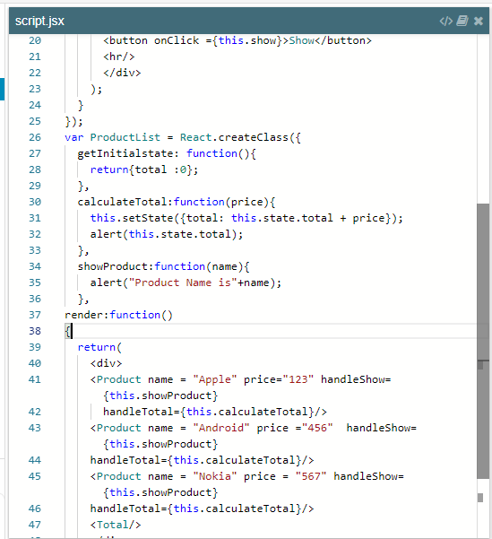

Working with Array

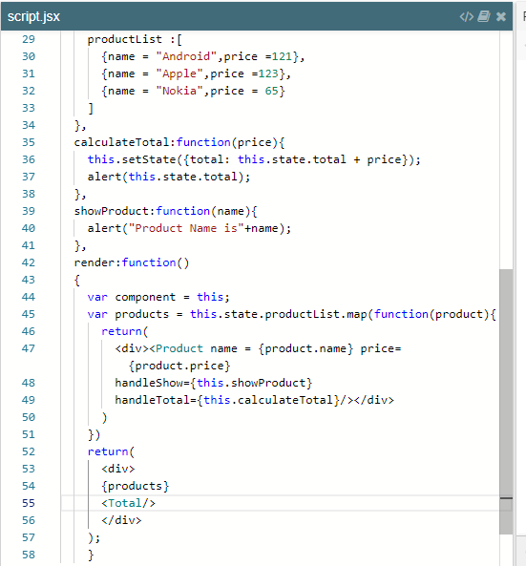

Working with Form component

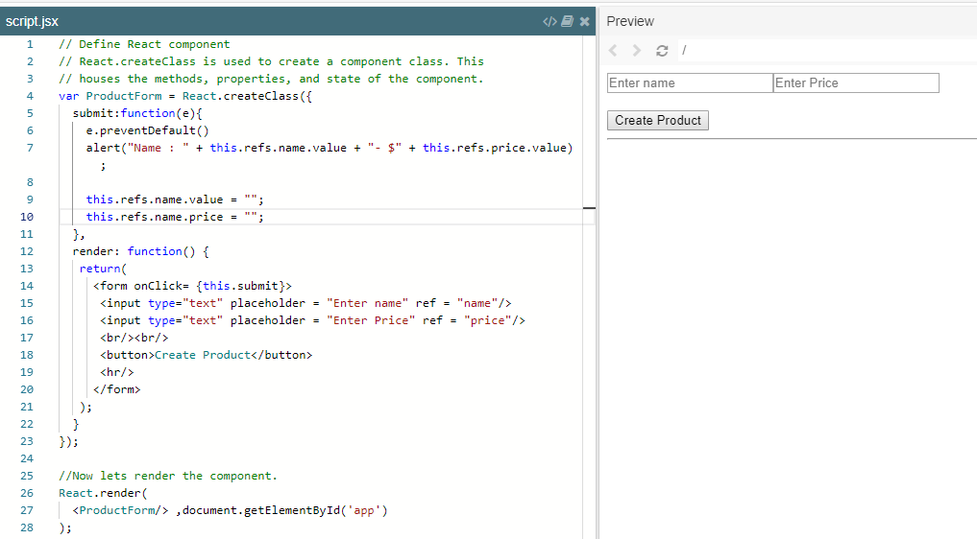

Working with Create component

